**RED TEAM**

**Summary of Operations**





**Table of Contents**

* Exposed Services
* Critical Vulnerabilities
* Exploitation
* Appendix A
* Appendix B

**Exposed Services**

The first step was mapping machines on the network using **netdiscover** tool. Results documented below:

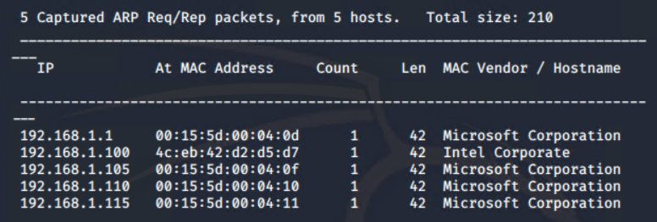

Then, using **nmap** tool, each devices ports and services were scanned for potential points of entry as well as to identify each machine on the network. Through scanning, it was apparent that the IP:**192.168.1.110** was indeed the Target 1 machine (due to its host name) that was to be the victim of this engagement. Below are the results for the **nmap** scan.

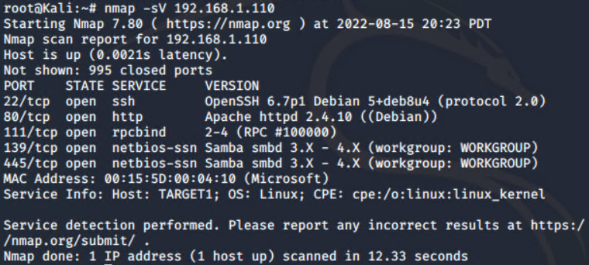

Command used: **nmap -sV 192.168.1.110**

**Critical Vulnerabilities**

Next, another **nmap** scan type was used to find potential vulnerabilities and points of entry into the machine. This was done using **nmap**’s NSE scripts which have the capability to test for vulnerabilities. The one being used in particular is a NSE script available through GitHub which is a module for turning **nmap** into a full vulnerability scanner, known as **vulscan**. Installation steps for **vulscan** can be found in Appendix A. The command used was:  
 **nmap -sV --script vulscan 192.168.1.110 -p 80,22**

The **vulscan** command used referenced service versions and protocols on ports **80** and **22** against multiple known vulnerability databases, such as **MITRE**. As such, the output is extremely large but provides fantastic insight for a penetration tester. The results for the first two databases are documented below as they include CVE numbers, any subsequent output can be found in Appendix B and is extensive.

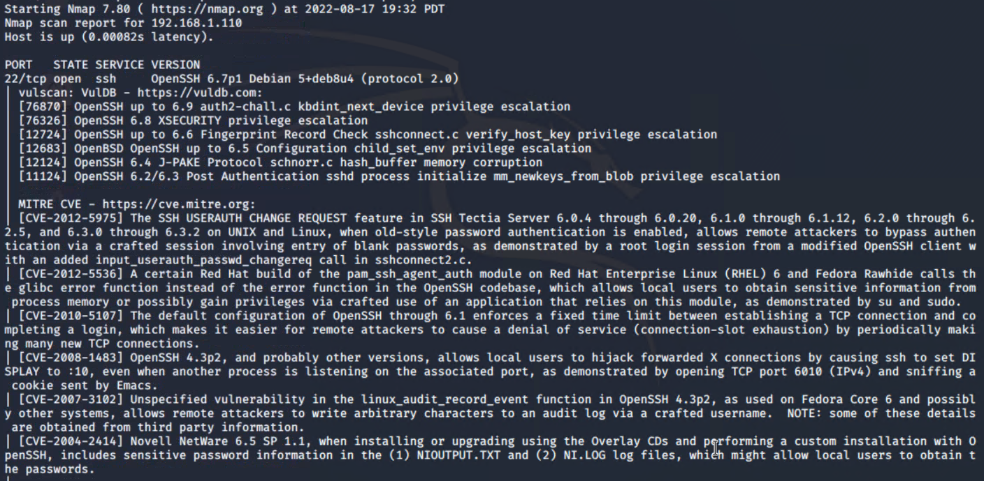

Two database outputs for port **22.**

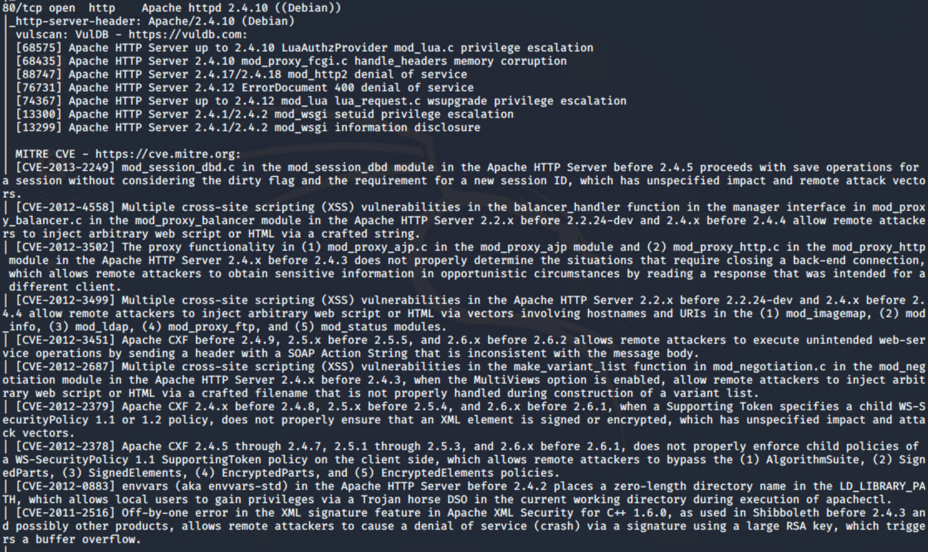

Two database outputs for port **80**.

Other vulnerabilities were also found whilst enumerating both the site and the Target 1 machine that gave valuable information away including:

* **Lack of Wordpress configurations**  
   Without defining it in the Wordpress configuration files, or without using the  
   known **block-wpscan**, the **wpscan** tool can be used to enumerate a large   
   amount of information from Wordpress servers, including usernames.   
   Detailed further in the next section.
* **Use of SSH password instead of keys** Using brute force tools, it was possible to crack a users password and log  
   into the server through SSH using his credentials. This process would be  
   exceedingly harder and more time consuming if SSH keys were in use   
   instead of potentially weak passwords. Details documented in the next  
   section. Below is a great diagram showing the difference in strength between  
   the two authentication methods.  
   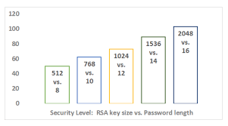  
   <https://thorntech.com/passwords-vs-ssh/>  
   Interesting to note that even a **12** letter password, which is only just becoming   
   common practice, is only as strong as 1024 bit key size. Standard key lengths  
   these days are typically 2048 bits to 4096 bits.
* **Sensitive passwords stored in plain text**  
   During the engagement, highly sensitive passwords relating to root access to   
   the servers MySQL database were discovered and could easily be read as   
   they were stored as plain text. This is a massive critical vulnerability as it   
   allowed attackers direct access to sensitive information on the database,   
   including all database tables as well as users password hashes. Ideally, any   
   passwords stored on a system should be in a hashed format or stored in an   
   encrypted format.

**Exploitation**

During the engagement, the Red Team was able to penetrate `Target 1` and retrieve the following confidential data. Please refer to the presentation for further detail behind the steps taken to find each flag.

* `**flag1**`  
  This flag was found inside the HTML of the web server itself. The only reason this flag was found as during the website enumeration process, HTML elements were inspected, and upon inspecting the elements contained on the page [**http://192.168.1.110/service.html**](http://192.168.1.110/service.html), the flag was found located below the footer section of the webpage HTML. If this flag genuinely was sensitive data, it would be worth adding a level of code obfuscation to the HTML to make it harder to find.

Here is a screenshot depicting this find:

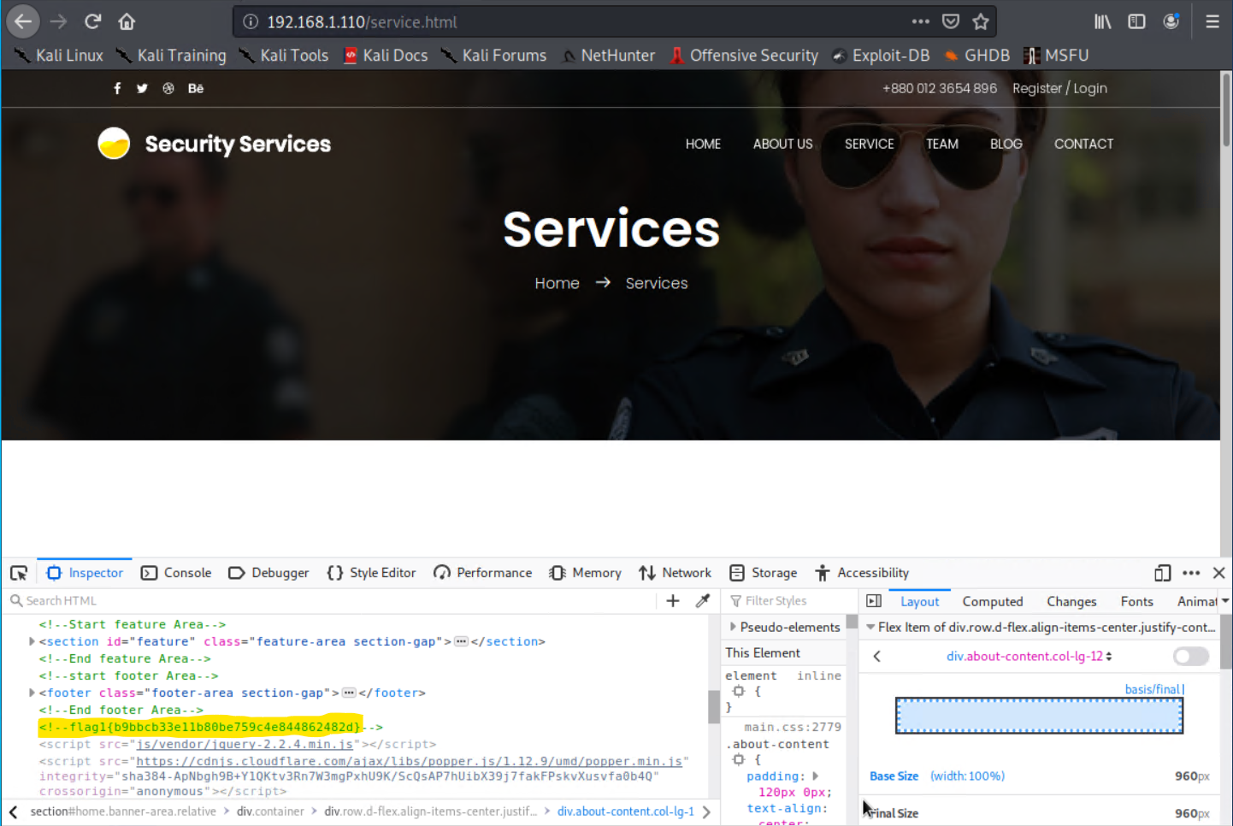

* `**flag2**`:  
  The next flag was found after access was obtained to the user account **michael**. The user account was enumerated using the **wpscan** tool, a well known tool for testing security on Wordpress servers. The command used to find the user **michael**, along with the user **steven** was as follows:  
    
  **wpscan --url** [**http://192.168.1.110/wordpress**](http://192.168.1.110/wordpress) **--enumerate u**

Running this command gave the following output:  
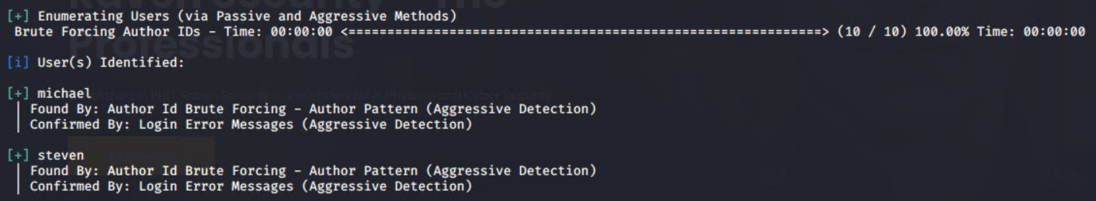  
First, attempts were made to gain access to the **michael** account.

Access to this account was possible through the use of the **Hydra** brute force tool, shown below to find the password for the account: **michael**.

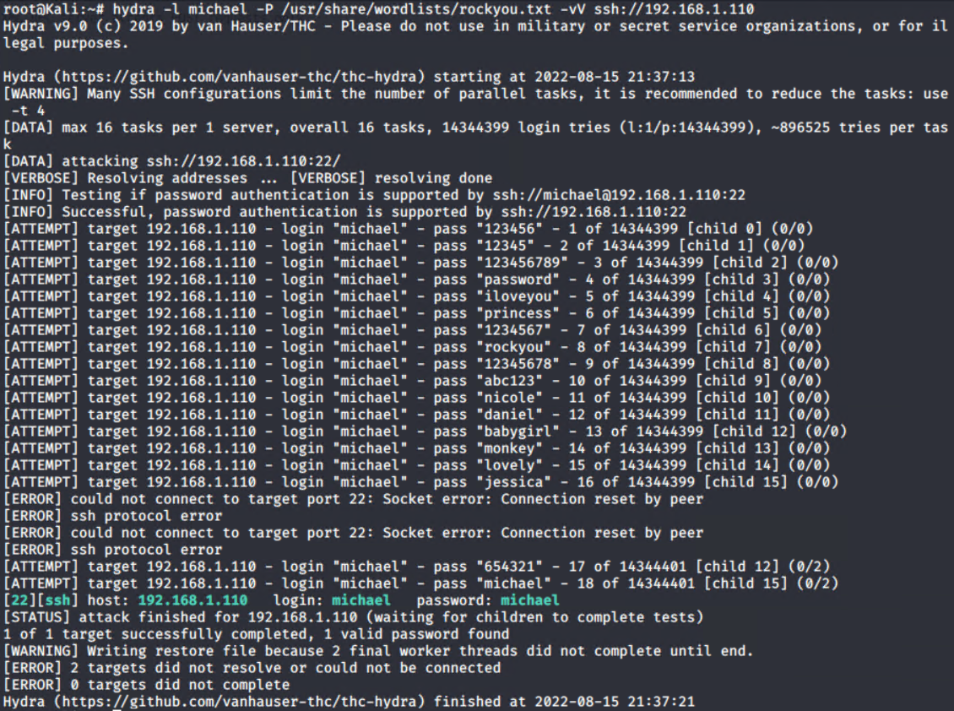  
  
Once this account could be accessed, it was possible to travel to the directory that holds the HTML data, under the path **/var/www/html**.  
  
Whilst traversing to this directory, each parent directory was checked and its contents verified. This is where the second flag was found. Located in the **/var/www** directory, the file **‘flag2.txt’** was found and after using the **cat** command on the file, the sensitive data stored within could be accessed. Below is a screenshot showing this flags location and its contents:  
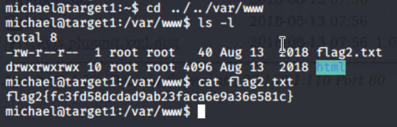

**flag2: {fc3fd58dcdad9ab23faca6e9a36e581c}**  
  
Note: the above screenshot was taken while logged into the target machine as the user account **michael**.

* ‘**flag3’:**  
  The third flag, of four, was found inside the web server’s MySQL database. The database it was located in was called **wordpress** and the table within that held the flag in question. The table was called **wp_posts**. This was located after a plain text password for root access to MySQL was found in the **wp-config.php** file, a file included with Wordpress servers for configuration options and plugins. This config file was found two directories below flag2, in the path **/var/www/html/wordpress**, and was found due to further enumeration of subfolders in the **/var/** directory whilst logged in as the user **michael**:

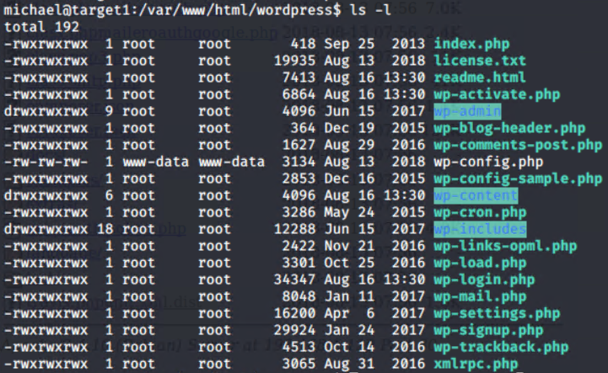  
The subsequent password found inside the file was: **R@v3nSecurity**The contents of **wp-config.php** are shown below:  
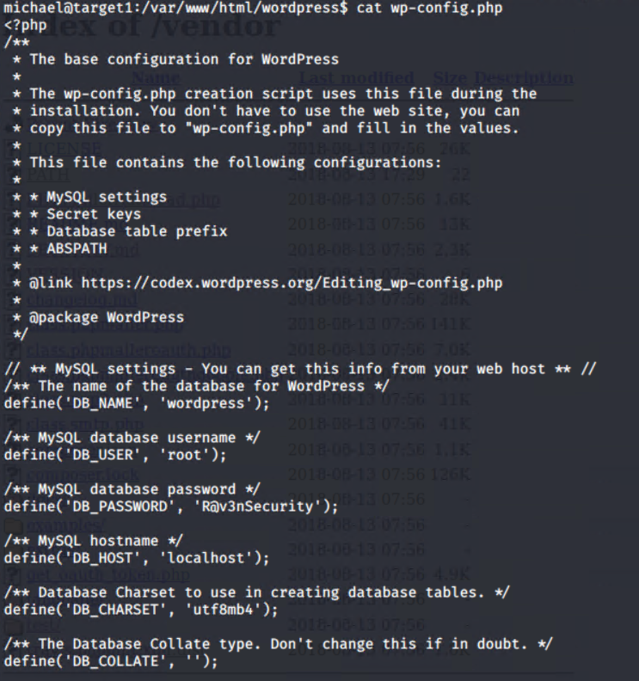

Once this password had been discovered, it was a matter of being able to log into the MySQL databases and dump all their contents to a file called **wp-hashes.txt**.

This was done with the **mysqldump** tool with the following command:  
  
This dump allowed us as an attacker to then use the **grep** tool to filter through the output file for any strings containing **“flag”**, **“flag3”** or **“flag4”**. Through this method, the flag3 (highlighted) value was found:  
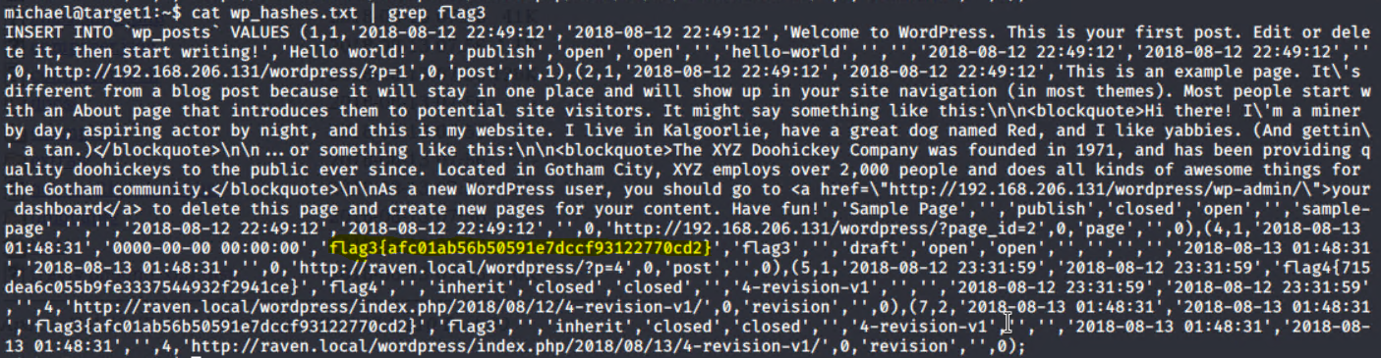  
**flag3: {afc01ab56b50591e7dccf93122770cd2}**

* ‘**flag4**’:  
  The fourth and final flag on the Target 1 system was found after root access to the server was obtained on the server. To get to this point, the user steven had to be logged into. When creating the MySQL dump referenced above for **flag3**, the tool also dumped the contents of the **wp_users** table, containing the hashed password values for both user accounts **michael** and **steven.**

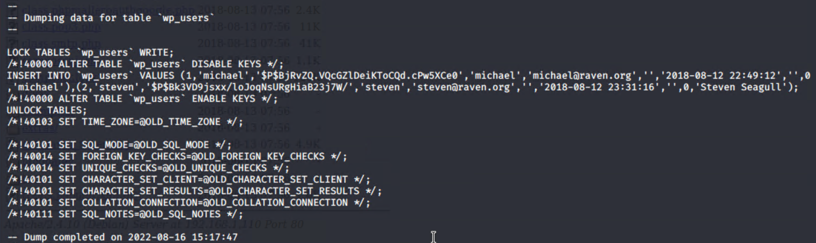  
These hashed password values were then copied to the clipboard and pasted on the Kali (attacker) machine in a new file called **hashes.txt**. From here, the tool known as **John the Ripper** could be used to crack the password hashes. This process managed to crack **steven**’s password: **pink84**  
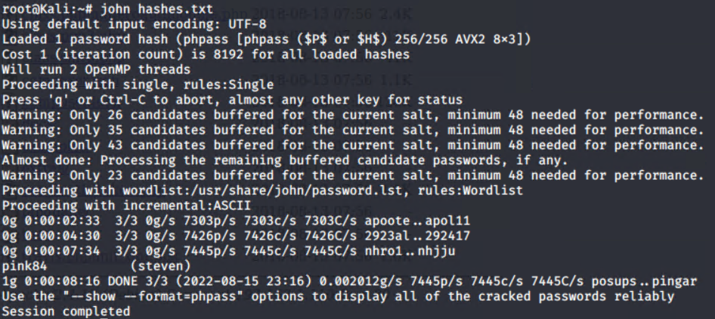

The user account **michael** was then logged out of and a new SSH connection was made to the server as the user **steven**. Upon gaining access to this account, the **sudo -l** command was run, to show potential privileges or points of escalation. In this case, the user account **steven** had been given permission to use all Python commands using the **sudo** prefix:  
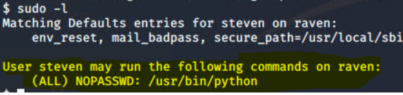

Using this privilege, a root shell was able to be accessed. Using a simple Python trick to initiate a root shell with Python itself using the **sudo** command, it was possible to escalate privileges all the way from **steven** as a user account, to root. The Python exploit documented below:  
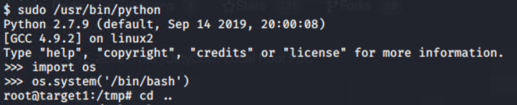

As seen above, root access was obtained. At this point, other directories were to be looked into that users **michael** and **steven** could not access, such as the **/root** directory. After navigating to said folder, the contents inside were listed out. Here is where the fourth and final flag was finally discovered, completing the engagement scope for this target.

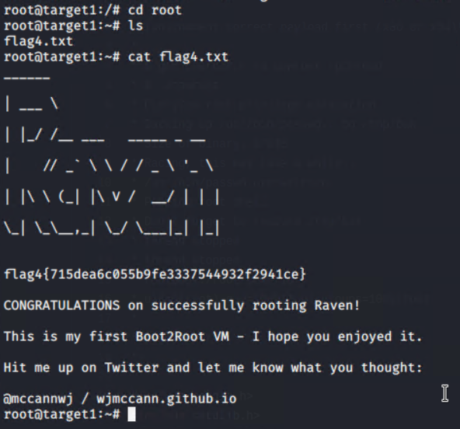

**Appendix A**

All information documented was sourced from <https://geekflare.com/nmap-vulnerability-scan/>

**Vulscan Installation Instructions:**  
  
1. Navigate to the Nmap scripts directory:  
   
 **cd /usr/share/nmap/scripts/**

2. Clone the vulscan GitHub repository and install all requirements:

**git clone** [**https://github.com/scipag/vulscan.git**](https://github.com/scipag/vulscan.git)

**ln -s ‘pwd’ /scipag_vulscan /usr/share/nmap/scripts/vulscan**

3. Vulscan scans against multiple well known exploit databases that are be saved locally

on the machine. This step is here to make sure these libraries are updated. First, navigate

to the updater directory included with vulscan:

**cd vulscan/utilities/updater/**

4. Update file permissions for the updater script located in the directory:

**chmod +x updateFiles.sh**

5. Finally, run the updater to update all databases used by vulscan:

**./updateFiles.sh**

**The Vulscan module is now ready to use with Nmap!**

**For further tips on usage and options, please refer to the link below:**

[**How to Use Nmap for Vulnerability Scan? - Geekflare**](https://geekflare.com/nmap-vulnerability-scan/)

**Appendix B**

**Extended Vulscan Output**

Below is the extended port 22 output from vulscan referenced in the **Critical Vulnerabilities** section. Vulscan is an extensive tool and provides great insight into a machine and its possible vulnerabilities. Whilst many parts of the output overlap with databases that share entries, it is shown in full here to show the scope of the tool in its most simple command format. Another thing to note is this is the enumeration from **just** port 22. To include the port 80 results as well would be to add five more pages to this document, which is unnecessary.

